Exp.No-20
20. Perform Sharpening of Image using Laplacian mask with negative centre coefficient.

Aim:
To sharpen an image using a Laplacian mask with a negative centre coefficient.
Procedure:
- Start the program.
- Import OpenCV and NumPy.
- Read the input image (v.jpg).
- Define the Laplacian sharpening kernel.
- Apply the kernel using filter2D().
- Display the original and sharpened images.
- Save the output image.
- Stop the program.
Program:
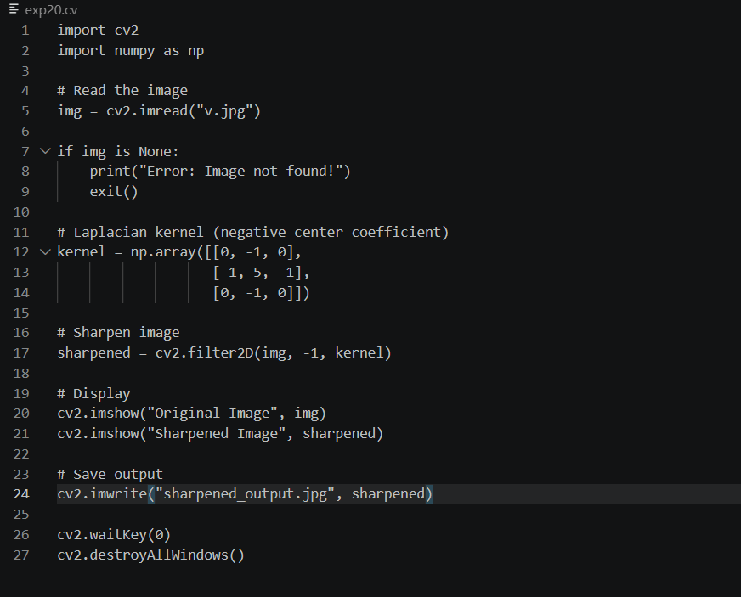

Input:
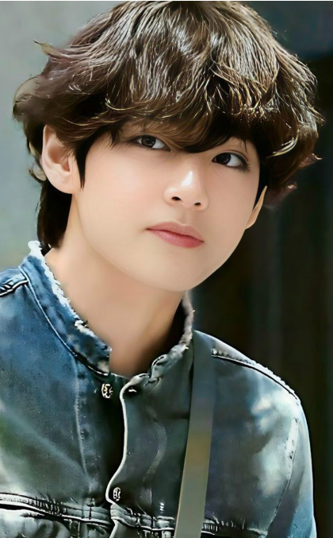

Output:
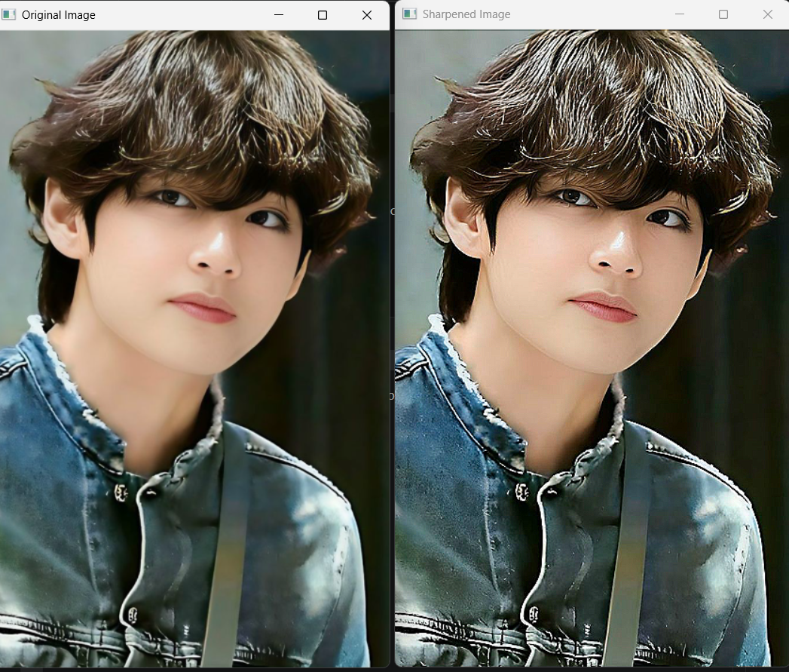

Result:
The input image was successfully sharpened using the Laplacian mask with a negative center coefficient, and the sharpened image was displayed and saved successfully.

